Recommender Systems - Course Project Report - WIP
Team | Group 1
Members | Farzana Yasmin, Berk Peker, Emil Ålgars
For Part 3 track: select one | A / B / C
GitHub repository link | https://github.com/berkpeker2707/recommender-systems-group1

1. Part 1 - Data, Protocol and Baselines

1.1 Data characterization
MovieLens 1M contains 1,000,209 ratings (1–5 stars) from 6,040 users on 3,706 movies. The catalogue (movies.dat) lists 3,883 movies, 177 of which were never rated. The rating matrix is 4.47% filled (4.26% if the never-rated movies are counted), denser than the 1% or less typical of real systems (L1.1 s6), partly because every user has at least 20 ratings by construction.
Long tail (L5.1 s5; Figure 1). Popularity is highly concentrated. The most-rated movie has 3,428 ratings (57% of all users), while 623 movies, including the 177 never rated, have fewer than 10. The top 10% of the catalogue collects 45.7% of all ratings and the top 20% collects 66.7%. User activity is also skewed: the mean number of ratings per user (166) is well above the median (96). A typical movie has 124 ratings (median), but the mean is 270, because a few blockbusters pull it up. Because the test data share this concentration, recommending popular movies already scores well on accuracy, which is why Most Popular is a strong baseline (Section 1.6).
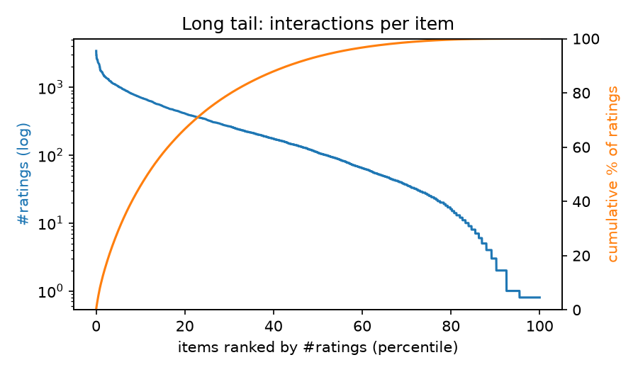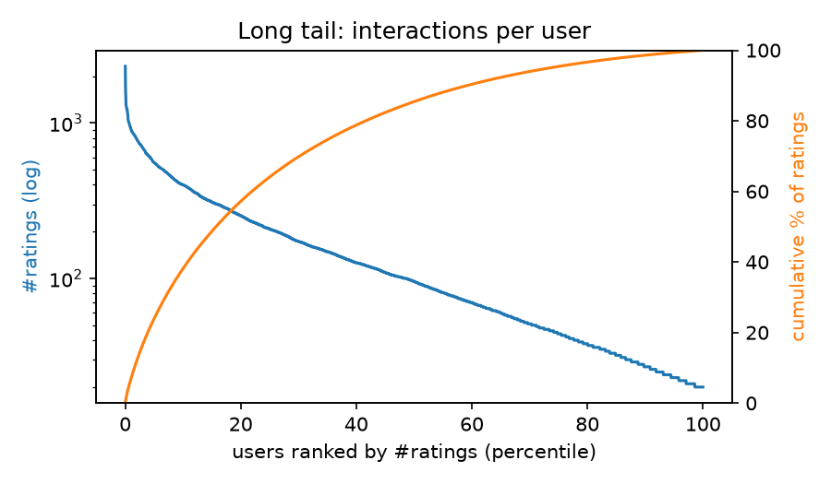
Figure 1. Ratings per movie (left) and per user (right), sorted from most to least rated (blue, log scale; never-rated movies drawn at 0.8), with the cumulative share of ratings (orange).
Ratings and time (Figure 2). Users rate generously: 4 stars is the most common rating (34.9%), and 57.5% of ratings are 4 or 5. Ratings run from 25 April 2000 to 28 February 2003, but 90.5% were entered in 2000, and 58.7% of users entered all their ratings on a single day. Timestamps therefore record when a rating was entered, not when a movie was watched. Because our split cuts by rating count (Section 1.3), validation covers only 27 days of December 2000 while test covers 26 months. Many validation users first rated in that month and have no training history (611 of 1,134), so after filtering item-kNN was tuned on only 490 users, against 1,154 in the test set.
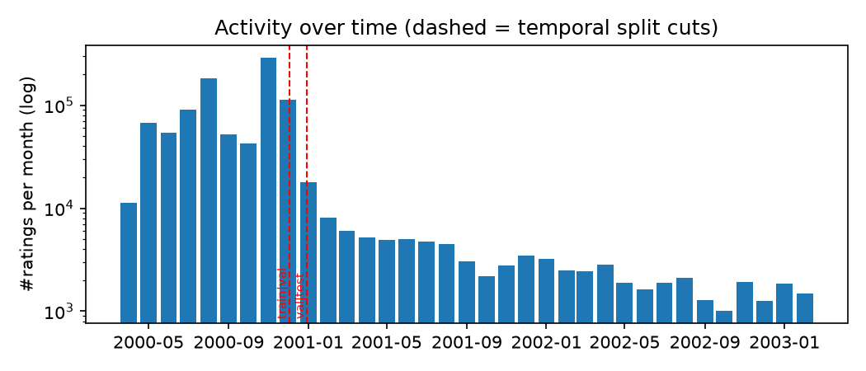
Figure 2. Ratings per month (log scale). The left dashed line is the train|validation cut (2 Dec 2000) and the right one is the validation|test cut (29 Dec 2000).

1.2 Preprocessing and feedback treatment
Data is kept and no movie or rating is deleted. The model learns from all ratings and picks its recommendations from all 3883 movies. If we deleted rare movies, the task would be easier and the results would look better than they are.

The filter only decides which users are measured, according to two conditions:
a) The user should have at least 5 ratings in the training data. Otherwise the model knows almost nothing about the user.
b) The user should have rated at least one movie 4 or 5 in the period we check. Otherwise there is no correct answer, and recall and NDCG cannot be calculated.
Users who are not measured still stay in the training data.
Feedback: The system's job is to recommend 10 movies to each user. The past is recorded as 0/1. The star the user gave is not important; whether the user rated the movie or not is important. Correct answers are movies rated 4 or 5. A rating of 3 is neutral, so it is not counted as liked. Star values are used only by adjusted cosine and pop_alltime_positive.

1.3 Train/validation/test split
The ratings are sorted by time and cut at two points. The oldest 80% is training data, the next 10% is validation and the newest 10% is test.
- First cut: 2 Dec 2000 14:52 (training ends, validation starts)
- Second cut: 29 Dec 2000 23:43 (validation ends, test starts)
Dividing by time is essential. In real life a system only knows the past and has to guess the future. If we split randomly, the model could learn from ratings that were given after the ratings it is tested on. It would see the future, and the results would look better than they are which would be false positive.
The 80:10:10 ratio is a common choice, not a calculated one. We also tried 90:5:5. Validation got more users and test got fewer, but the results barely changed, so we kept the 80:10:10 ratio.
We cut at a time, not at a row number. So ratings given in the same second always stay in the same split.
Validation is used only to choose settings, for example k in item kNN. After that, the final model learns from training + validation and is tested once on test phase.
The detected problem is; ratings are not spread evenly over time(!). Validation covers only 27 days, but test covers about 26 months. 611 of the 1,134 validation users are new and have no training ratings, so only 490 users are measured in validation. The settings are chosen with these 490 users, and they may not be like the 1,154 test users.

1.4 Evaluation protocol
For each user, the model ranks all 3883 movies except the ones the user already rated in the training data. We do not use a small random sample of movies, because a sample can give a different winner than the full list, as mentioned in the prior section. If two movies have the same score, the one with the lower index comes first, so every run gives the same result. The seed is 42.
We take the top 10 for each user and calculate:
- Precision@10: how many of the 10 recommended movies are correct answers
- Recall@10: how many of the user's correct answers are in the 10
- NDCG@10: like recall, but a hit near the top gets more points than a hit near the bottom. This is our main metric.
These are averaged over all measured users. We also calculate catalogue coverage: the share of the 3883 movies that appear in at least one user's top 10. It shows whether the model gives the same few movies to everyone.
For NDCG@10 we also give a 95% confidence interval. For example, 0.219 ± 0.014 means the real average is very likely between 0.205 and 0.233.

1.5 Baseline methods and settings
Item-based kNN (L1.2 s5–10). For every pair of movies we compute a similarity from the users who rated both, and keep each movie’s k most similar neighbours, dropping negative similarities. A user’s score for an unseen movie is the sum of its similarities to the movies the user has rated, and the ten highest-scoring movies are recommended. We tuned two settings on the validation set. The first was the similarity measure: cosine on raw ratings, adjusted cosine (which subtracts each user’s mean rating first) and Jaccard (which uses only who rated what). The second was k ∈ {10, 20, 50, 100, 200}. Adjusted cosine with k = 50 had the highest validation NDCG@10 (0.127), ahead of the best cosine (0.101) and Jaccard (0.106) runs, both at k = 200. The measure is a clear choice; k is not. Adjusted cosine scores 0.127, 0.125 and 0.126 at k = 50, 100 and 200, differences far smaller than the ±0.018 interval, so any of the three would be defensible.
Most Popular (L1.1 s9). Each movie is scored by its number of ratings in the fitting data, and each user receives the ten highest-scoring movies they have not rated. We report three variants:
- all ratings over all time;
- only ratings of 4 or 5, the same threshold our metrics use for relevance;
- all ratings from the 90 days before the cut, to test whether recent popularity predicts better.
The 90-day length was not tuned. Because ratings are concentrated in late 2000 (Figure 2), this window still holds 49.1% of the ratings used for the test run, so it is not much more recent than the full history.

1.6 Results and analysis
Table 2. Test-set results (seed 42; 1,154 users; NDCG@10 with 95% CI).
Model | P@10 | R@10 | NDCG@10 | Coverage
Most Popular, all time, all ratings | 0.185 | 0.052 | 0.200 ± 0.014 | 3.8%
Most Popular, last 90 days, all ratings | 0.187 | 0.054 | 0.202 ± 0.014 | 3.2%
Most Popular, all time, ratings ≥ 4 | 0.195 | 0.057 | 0.212 ± 0.014 | 3.6%
Item-kNN, adjusted cosine, k = 50 | 0.200 | 0.065 | 0.219 ± 0.014 | 14.3%

Accuracy. Item-kNN has the highest NDCG@10 (0.219). The best popularity variant is only 0.007 lower (0.212), and the 95% intervals overlap, so we do not claim item-kNN is more accurate. Both models are scored on the same users, so a paired test on per-user differences would be more sensitive than comparing intervals. A popularity baseline coming this close is what the long tail in Section 1.1 predicts: the top fifth of the catalogue collects two-thirds of all ratings. Counting only positive ratings helps popularity (0.212 vs 0.200). Restricting to the last 90 days barely changes it (0.202), as expected from a window holding half the data.
Coverage. Item-kNN recommends 14.3% of the catalogue to at least one user, about four times more than the best popularity variant (3.6%). Popularity gives every user nearly the same list.
Filter sensitivity. We evaluate only users with at least 5 training ratings (Section 1.3), and reran with thresholds of 1 and 20 to see whether this matters. At 20, the best popularity variant drops by 0.0053 but item-kNN by only 0.0007, so the gap grows from 0.0066 to 0.0111. At 1, the gap is 0.0062. The ranking never changes, but the threshold moves popularity by almost as much as the gap we are measuring.
Validation versus test. Validation scores (about 0.12) are much lower than test scores (about 0.21), and the two should not be compared. The sets contain different users, and test users have more held-out ratings (83 on average, against 48), which makes it easier to place a relevant movie in the top 10. We use validation scores only to compare settings with each other.

2. Part 2 - Models and Honest Comparison

2.1 Models

2.2 Hyperparameter tuning and variability

2.3 Overall results

2.4 Disaggregated analysis

2.5 Sparsity ablation

3. Part 3 - Beyond Accuracy

3.1 Selected track and motivation

3.2 Method

3.3 Results and trade-offs

3.4 Cost and interpretation

3.5 "One number we cannot explain"

4. Discussion and Conclusions
Part 1: under a temporal split with full-catalogue ranking, item-kNN and Most Popular cannot be separated on NDCG@10, while item-kNN covers about four times more of the catalogue. The main limitation is tuning on 27 days and 490 users.

5. Contribution Statement
Farzana: Data loading and characterisation: parsing, data statistics, long-tail and activity figures, and Section 1.1.
Berk Peker: Evaluation protocol: temporal split, user filtering, evaluator, metrics and their tests, and Sections 1.2, 1.3, 1.4.
Emil: Baselines and reproducibility: Most Popular, item-kNN, tuning, results files, the run command, and Sections 1.5–1.6.

6. Use of AI Assistants
We used Claude Code (Anthropic) to draft code and documentation, to explain the code and lecture concepts, and to draft this report from our generated results. We reviewed and modified the code.

References
Course lectures L1.1, L1.2, L3.1 and L5.1, Recommender Systems course, Tampere University.
F. M. Harper and J. A. Konstan. The MovieLens Datasets: History and Context. ACM TiiS 5(4), 2015.
W. Krichene and S. Rendle. On Sampled Metrics for Item Recommendation. KDD 2020.

